**Week – 7**

**React**

**Objectives**

* **Define JSX**
* **Explain about ECMA Script**
* **Explain React.createElement()**
* **Explain how to create React nodes with JSX**
* **Define how to render JSX to DOM**
* **Explain how to use JavaScript expressions in JSX**
* **Explain how to use inline CSS in JSX**

**In this hands-on lab, you will learn how to:**

* **Use JSX syntax in React applications**
* **Use inline CSS in JSX**

**Prerequisites**

**The following is required to complete this hands-on lab:**

* **Node.js**
* **NPM**
* **Visual Studio Code**

**Notes**

**Estimated time to complete this lab: 60 minutes.**

**Create a React Application named “officespacerentalapp” which uses React JSX to create elements, attributes and renders DOM to display the page.**

**Create an element to display the heading of the page.**

**Attribute to display the image of the office space**

**Create an object of office to display the details like Name, Rent and Address.**

**Create a list of Object and loop through the office space item to display more data.**

**To apply Css, Display the color of the Rent in Red if it’s below 60000 and in Green if it’s above 60000.**

**Output:**

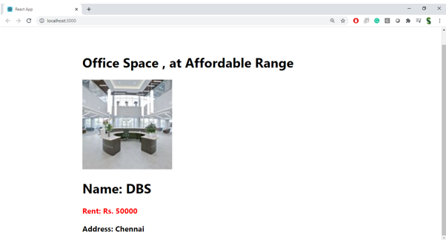

**Hint:**

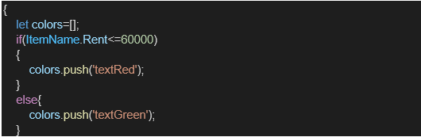

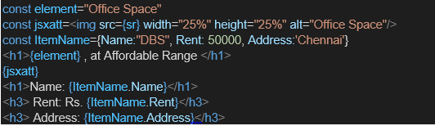

**IMPLEMENTATION :**

**src/App.js**

import React from "react";

import "./App.css";

function App() {

const offices = [

{

name: "DBS",

rent: 50000,

address: "Chennai",

image: "https://via.placeholder.com/400x250?text=DBS+Office" // replace with actual image

},

{

name: "Regus",

rent: 65000,

address: "Bangalore",

image: "https://via.placeholder.com/400x250?text=Regus+Office" // replace with actual image

}

];

return (

<div className="App">

<h1>Office Space, at Affordable Range</h1>

{offices.map((office, index) => (

<div key={index} className="office-card">

<img src={office.image} alt={office.name} />

<h2>

Name: <span>{office.name}</span>

</h2>

<p

style={{

color: office.rent < 60000 ? "red" : "green",

fontWeight: "bold",

}}

>

Rent: Rs. {office.rent}

</p>

<p>

<strong>Address:</strong> {office.address}

</p>

</div>

))}

</div>

);

}

export default App;

**src/App.css**

.App {

text-align: center;

font-family: Arial, sans-serif;

}

.office-card {

margin: 20px auto;

padding: 10px;

width: 500px;

}

.office-card img {

width: 400px;

height: 250px;

object-fit: cover;

border-radius: 10px;

}

h1 {

font-size: 2em;

margin-top: 20px;

}

h2 {

margin: 10px 0;

}

p {

font-size: 1.1em;

}

**OUTPUT :**

